AMITY SCHOOL OF ENGINEERING AND TECHNOLOGY WEEKLY PROGRESS REPORT (WPR)– 3

# For week commencing 27 June 2022 to 03 July 2022

Enrolment No. - A2305219303 Program - B. Tech CSE

Batch - 2019 - 2023

Student Name – Shashikant Solanki Faculty Guide's Name – Mr. Deepak Gaur

# Project Title:

Certificate Management System

# Targets set for the week:

# Completed the backend part of the PHP application and will begin the testing and debugging phase of various modules as well as making changes according to the client.

# Deployment of the application on heroku using heroku cli and github.

# Progress/Achievements for the week:

# We have completed the backend part of the PHP application and will begin the testing and debugging phase of various modules as well as making changes according to the client.

: -

1. PHP: All the back-end part i.e. taking input from the user and storing it in database and displaying the information to the user as well as the admin has been implemented in PHP.
2. MySQL: MySQL database has been used as database for the project.
3. I have used Blowfish algorithm to encrypt the password to improve security.
4. Project will be deployed on heroku.

Some of the some of the snaps of the application are listed below.

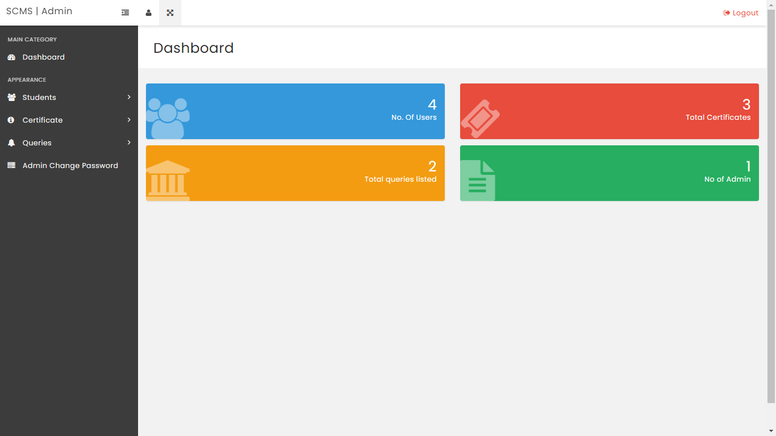

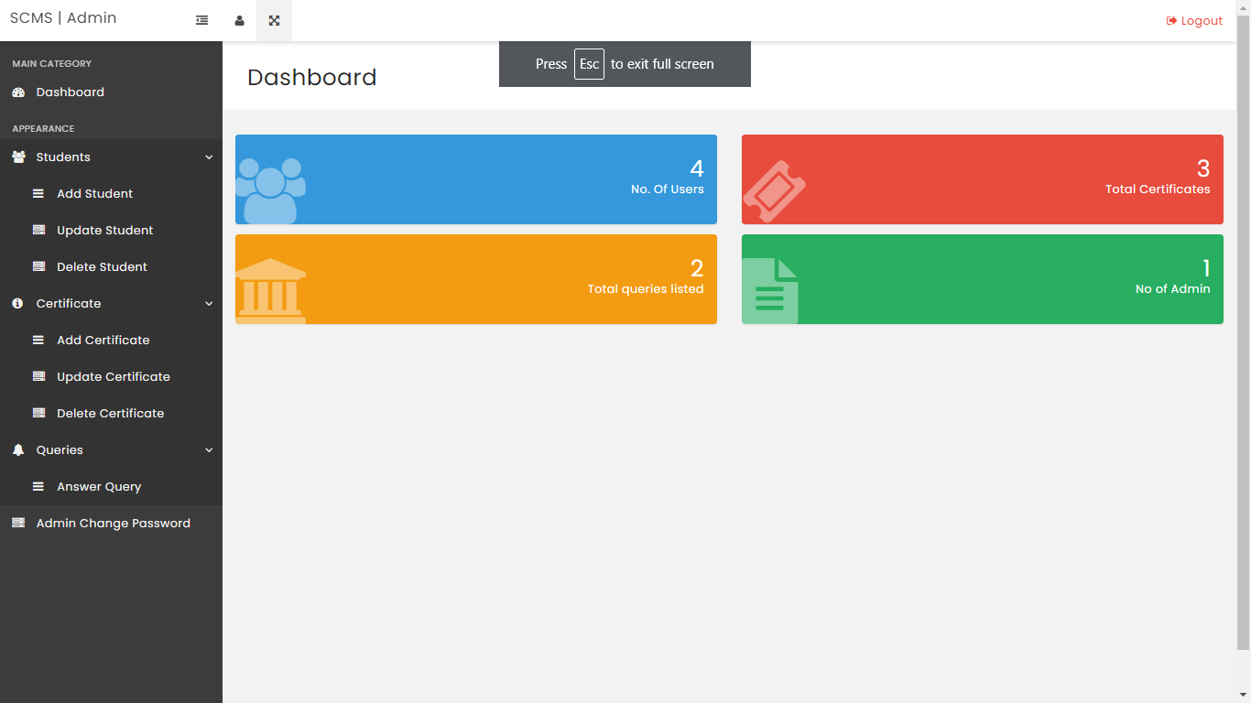

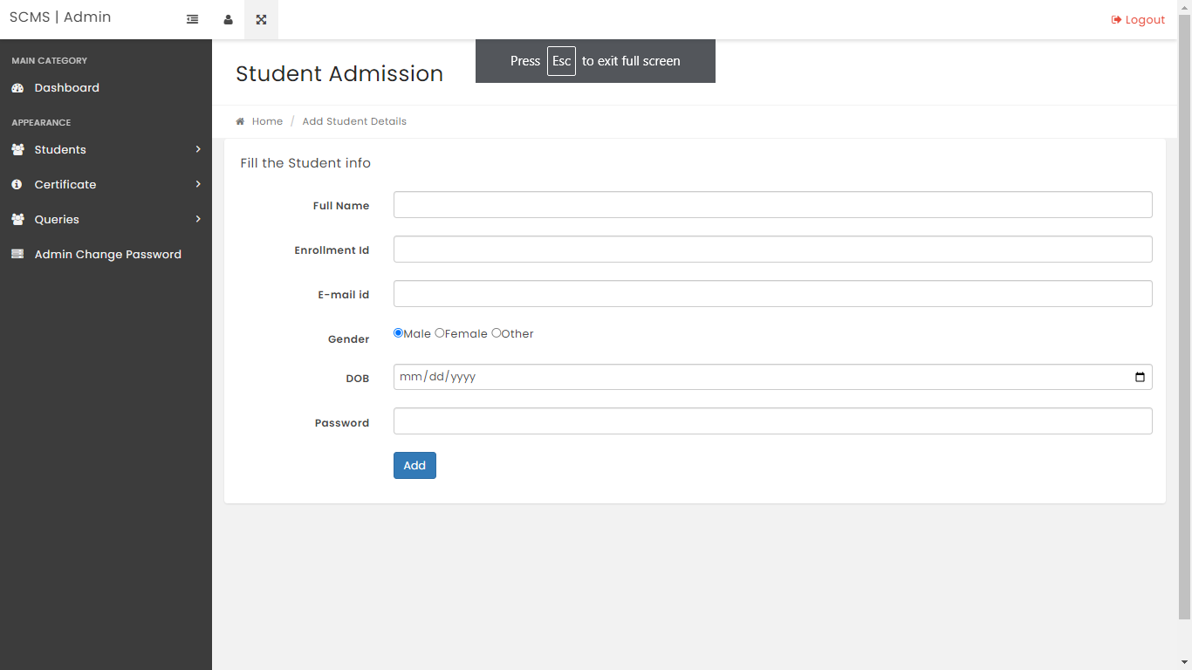

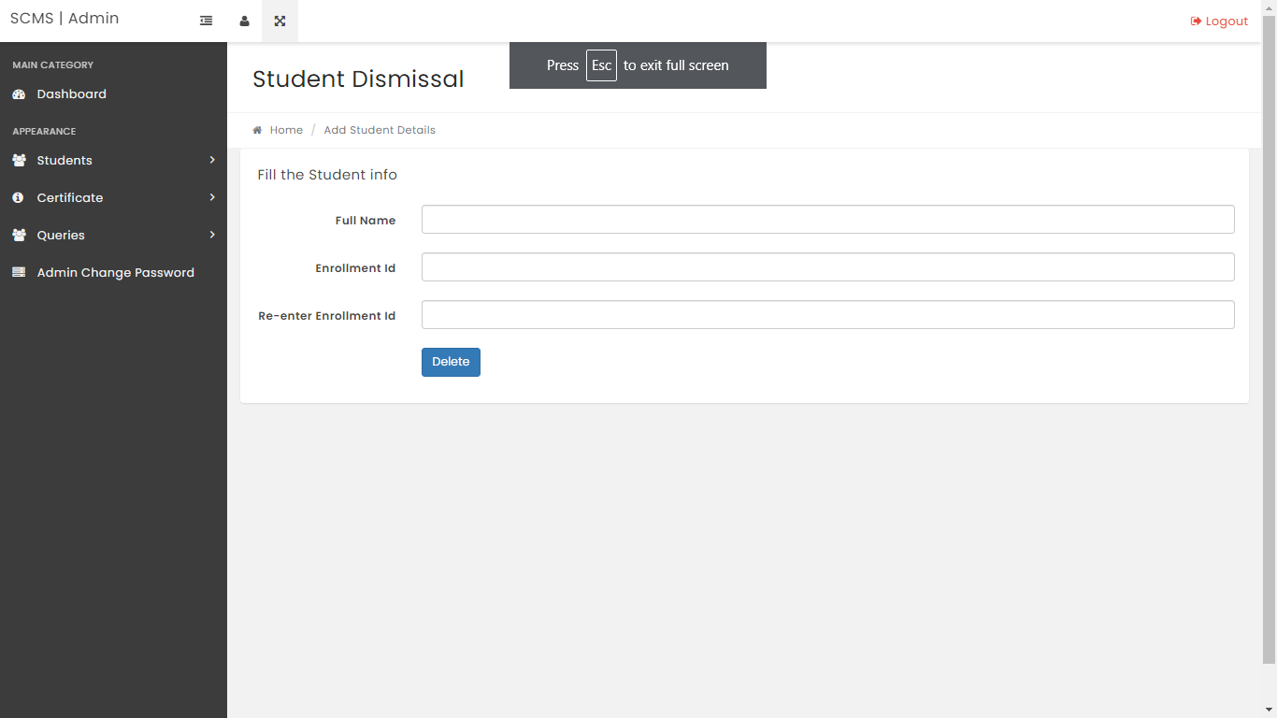

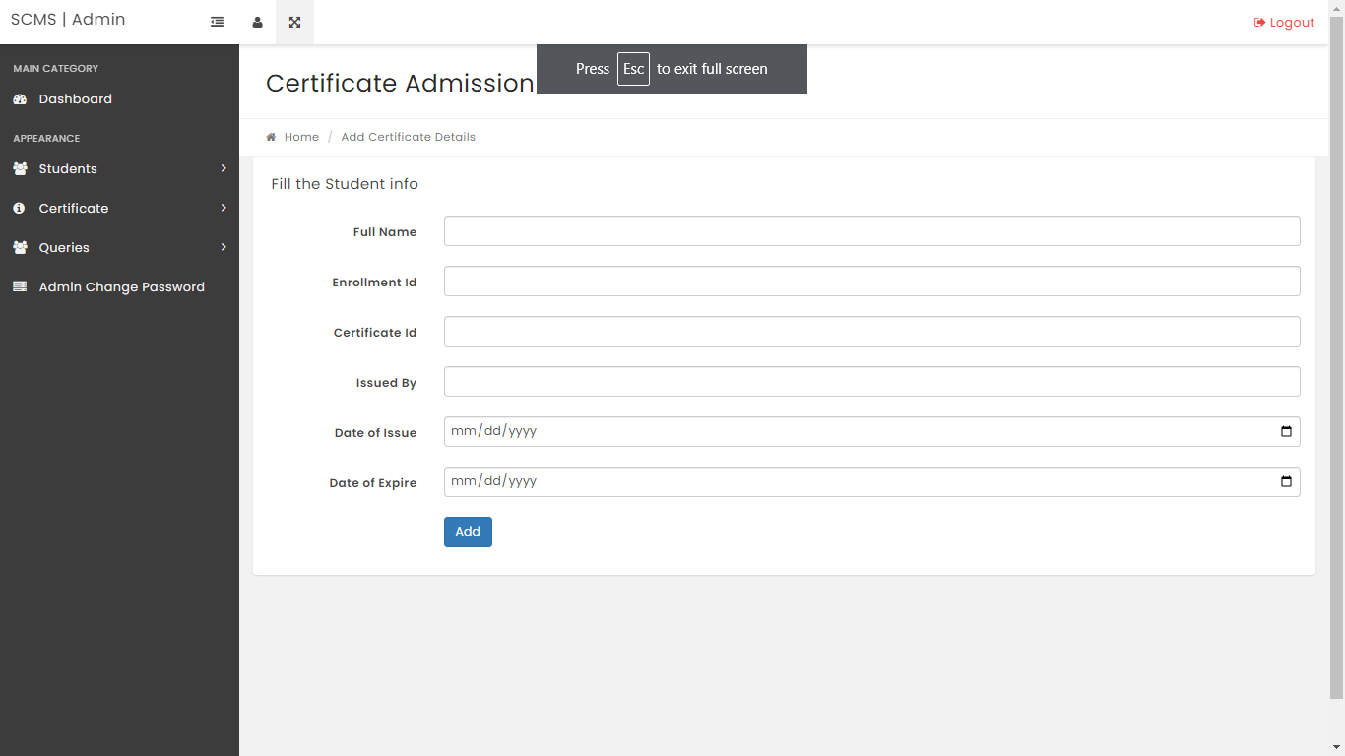

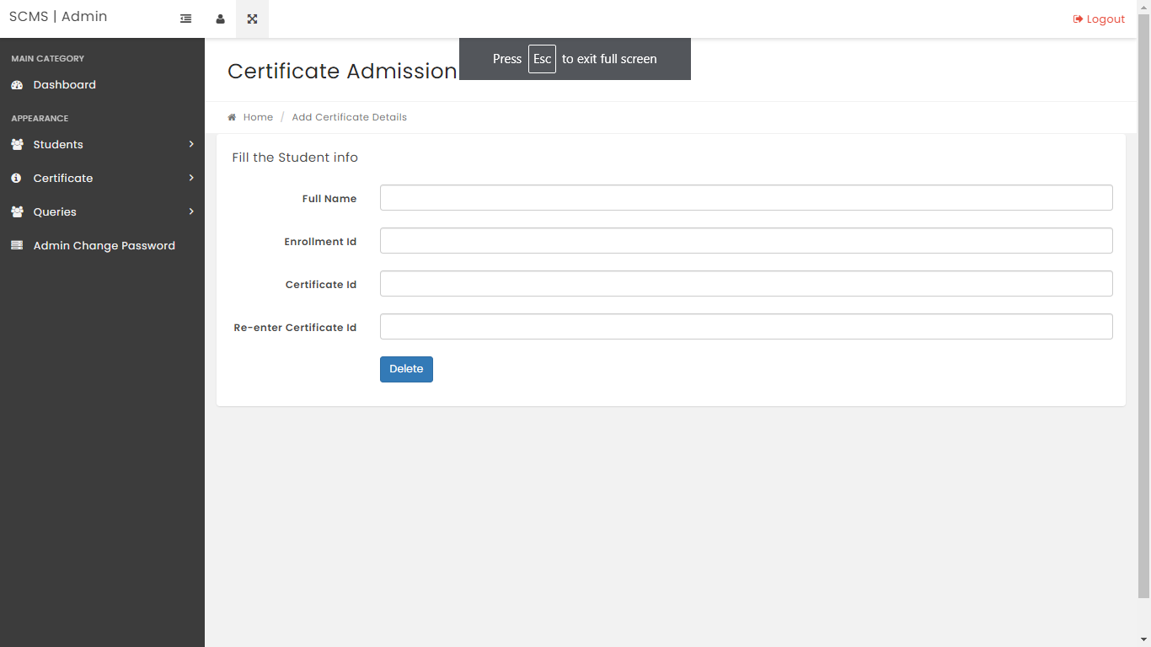

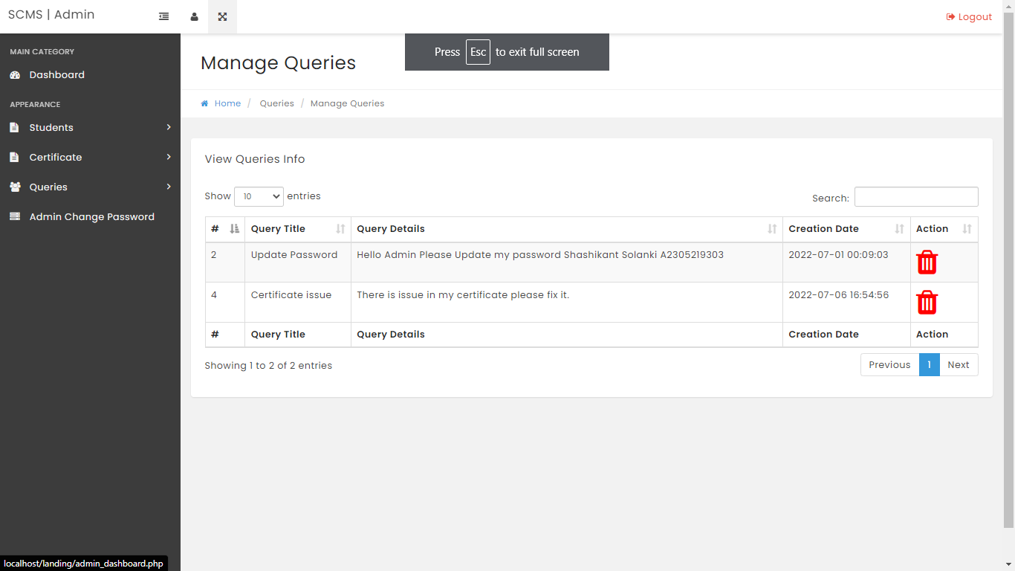

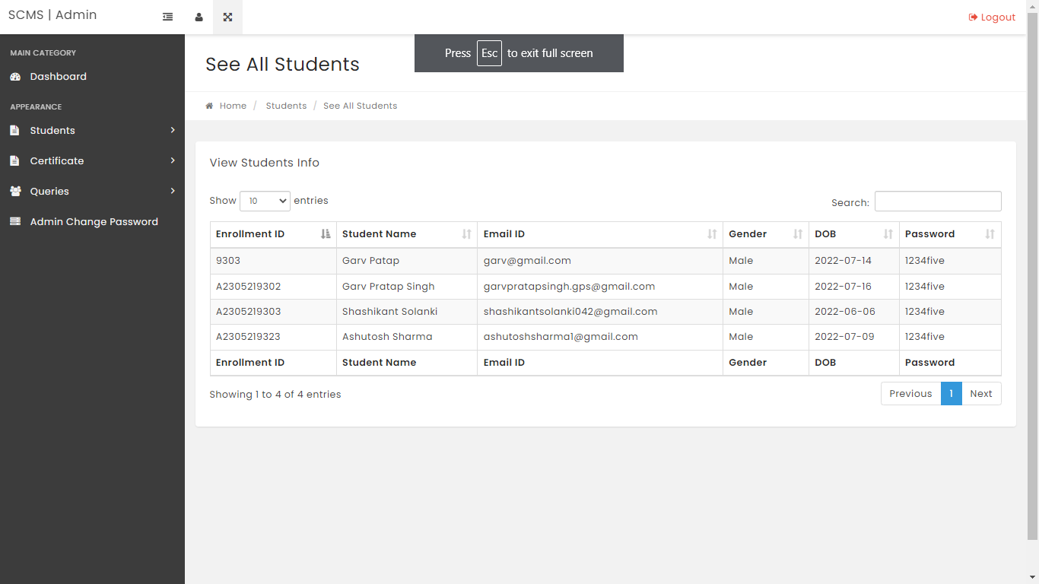

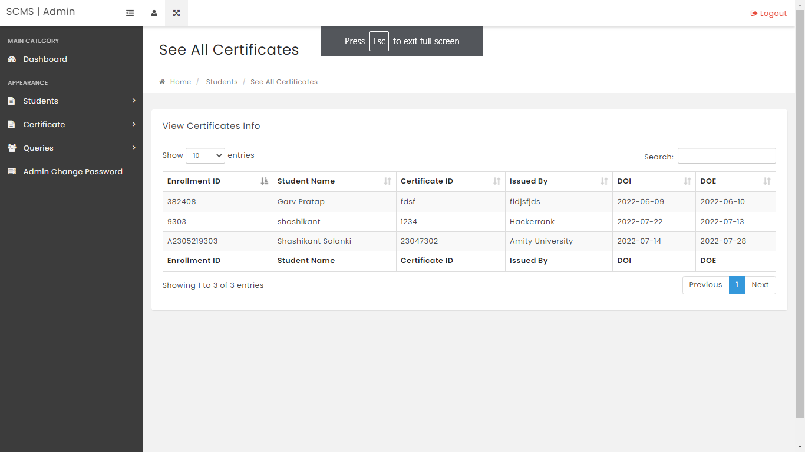

*These were some of the snaps from the admin portal*

Server used:-

XAMPP is the most popular PHP development environment. It is a completely free, easy toinstall Apache distribution containing MariaDB, PHP, and Perl.

# Future Work Plans:

We are exploring ways to validate the certificates and adding a QR code which can be scanned by the user for the authentication purposes.

Regards **Shashikant Solanki** 7-CSE-5(X)

References:

1. <https://github.com/intel-secl/certificate-management-service>
2. <https://www.appviewx.com/education-center/what-is-certificate-management/>
3. https:/[/www.freeprojectz.com/php-mysql-project/certificate-management-system](http://www.freeprojectz.com/php-mysql-project/certificate-management-system)
4. <https://errorworld.in/deploy-heroku-apps-that-use-mysql-without-a-credit-card/>
5. <https://www.doabledanny.com/Deploy-PHP-And-MySQL-to-Heroku>